Ideation Phase

Define the Problem Statements

Date | 08 December 2025
Team ID | SWUID202560312
Project Name | Freelance finder
Maximum Marks | 2 Marks

Customer Problem Statement Template:
To recognize the main obstacles freelancers face when searching for online work and use these findings to enhance the Freelance Finder platform.
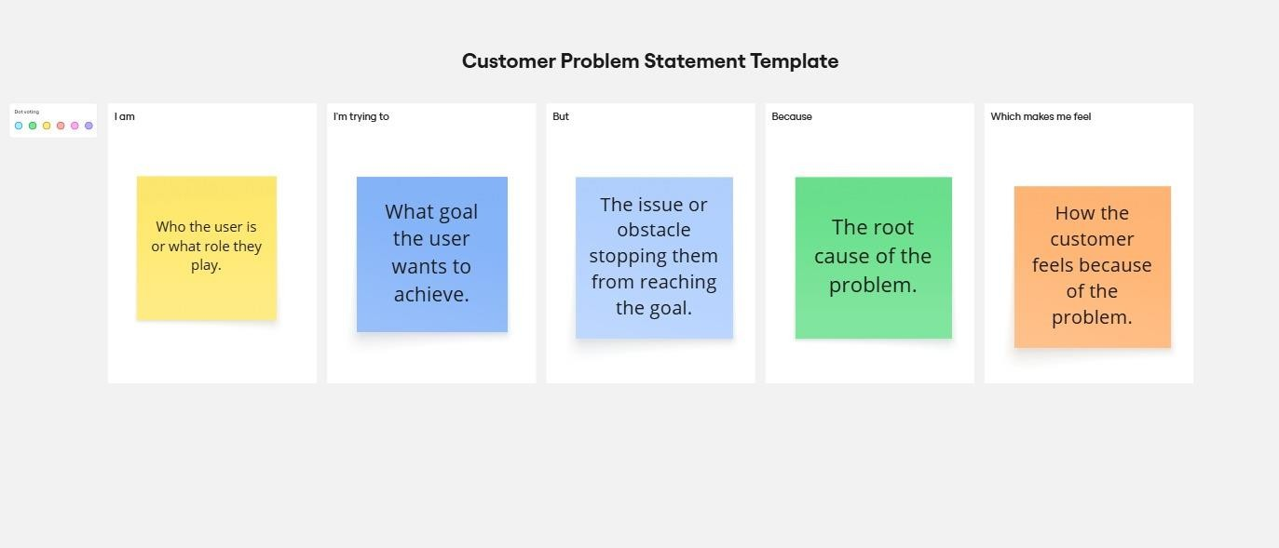

Reference: https://miro.com/templates/customer-problem-statement/

Problem  Statement (PS) | I am  (Customer) | I’m trying to | But | Because | Which makes me feel
PS-1 | a self- employed web developer. | obtain steady and meaningful project assignments | popular platforms are overcrow ded with applicant  s. | Clients mostly go for low cost instead of evaluating talent. | overlooked, less confident, and hesitant to apply for new projects.
PS-2 | a freelance graphic  designer. | present my work in a  strong and | the platform  offers | existing design and  branding | restricted, less visible, and unable to

 |  | visually appealing way to attract clients. | limited flexibility for customizi ng my portfolio. | tools are basic and do not support creative personalizati on. | showcase my true potential.

/

